ULTRASONIC TESTING REPORT
Company/Client |  | NCOC N. V. |  | Project |  | ESKENE WEST |  | Location |  | Sulphur Tr 2
Line No/Tag No: |  | A1-3312-GA-005-4”-A17-WN |  | Material |  | A333 Gr.6 SMLS |  | Día × Nominal Thickness |  | According to table
Procedure No: |  | QP-11-UTT-Q01 Rev 03  GOST 28702-90 |  | Calibration Block |  | CS Step wedge |  | Probe  S/N |  | D790  1058416
 |  |  |  | Calibration block Range |  | 2.50-25.00 mm |  | Angle |  | 0º
Manufacturing Code |  | ASME B31.3 |  | Calibration Temp |  | +25º |  | Frequency |  | 5 MHz
 |  |  |  | Object Temp |  | +35º |  | Size |  | 11 mm
Acceptance Standard: |  | Acc. to the client specif. |  | Correction factors |  | n/a |  | Crystal |  | Dual
Surface condition |  | Coated |  | Couplant |  | UT Gel |  | Accuracy |  | ± 0,1 mm
S. No | Equipment/  Material Name |  | Manufacturer |  | Serial No |  | Calibration certificate No |  | Calibration Expiry date
 | DL-38 |  | OLYMPUS |  | 171421601 |  | BK-01-0674 |  | 20-03-2020
 | Step wedge calibration block |  | NDE-TECH |  | NDE-8363 |  | - |  | -
Job description:

- UT measurements were conducted for thickness monitoring of pipeline.
- Echo-to-echo UT technique was used.
- UT spot check performed on top, bottom, extrados, North, South, East and West.
Notes:
N/A - not applicable.
FSH - Full Screen Height

Drawing
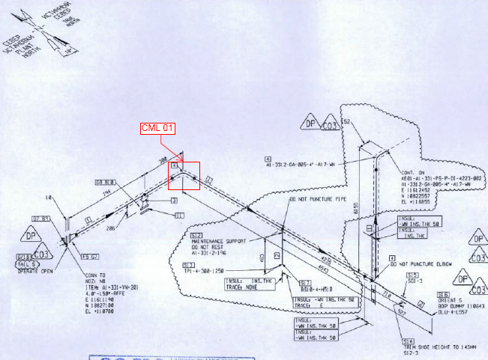
KE01-A1-331-PS-P-DI-4223-001 / A1-3312-GA-005-4”-A17-WN

Results
№ | Item description | DIA(Ø, inch | Nominal thickness, mm | Top, mm | Bottom, mm | East, mm | West, mm | North, mm | South, mm | Extrados,  mm | Intrados,  mm
CML-01 | Elbow | 4 | 11.12 | 12.08 | 11.67 | - | - | - | - | 11.00 | -

Drawing
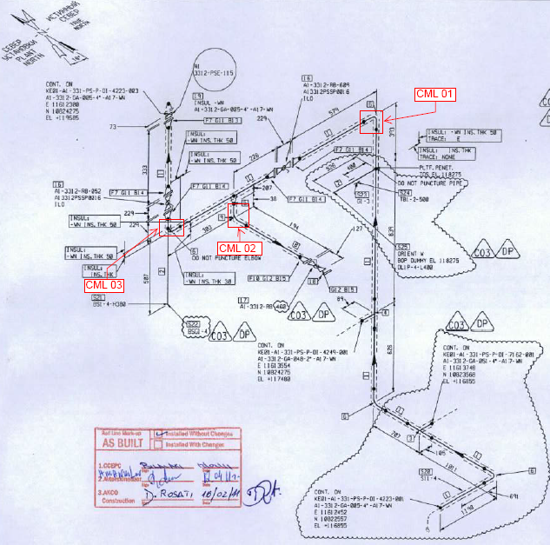
KE01-A1-331-PS-P-DI-4223-002 / A1-3312-GA-005-4”-A17-WN

Results, mm
№ | Item description | DIA(Ø, inch | Nominal thickness, mm | Top, mm | Bottom, mm | East, mm | West, mm | North, mm | South, mm | Extrados,  mm | Intrados,  mm
CML-01 | Elbow | 4 | 11.12 | - | - | - | - | 10.88 | 12.43 | 10.55 | -
CML-02 | Elbow | 1 | 9.09 | - | - | 9.75 | 8.98 | - | - | 9.22 | -
CML-03 | Elbow | 4 | 11.12 | - | - | - | - | 14.10 | 14.15 | 13.90 | -

Examined by  UT L II cert. No 356  expiry date: 28.04.2021 | Name: Dosbatyrov Damir | Signature: ............................. | Date: 18 Aug 2019
Approved by UT Level II  cer. No 1A 253/15  exp date: 31.05.2020 | Name: Shakunou Andrei | Signature: ............................. | Date: 18 Aug 2019
Client Representative: | Name: ………………………… | Signature: ....................................... | Date: ………………………

